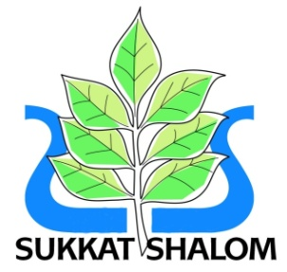 Sukkat Shalom Reform Synagogue

1 VICTORY ROAD HERMON HILL, WANSTEAD, LONDON, E11 1UL

Tel: 020 8530 3345 (Answerphone only)

[www.sukkatshalom.org.uk](http://www.sukkatshalom.org.uk) [admin@sukkatshalom.me.uk](mailto:admin@sukkatshalom.me.uk)

**Rabbi Larry Becker *MA***

**Honorary Life President: Frank Godson *BA***.

7 April 2021

Dear Members

**Board of Deputies of British Jews Triennium**

**Elections 2021 – 2024**

Please be advised that Joel Ilson and Stuart Jacobs were elected unopposed at the Special General Meeting, which was held on 6 April 2021, as our Deputies to attend meetings of the Board of Deputies of British Jews.

We do not have an under 35 Observer.

Yours sincerely

Angela Jacobs

Angela Jacobs

**Honorary Secretary**